Experiment 9: Hospital Information System
Aim
To create a simple cloud-based Hospital Information System for SIMATS Hospital using a cloud service provider to demonstrate SaaS.
Algorithm
1. Open Zoho Creator and create a new application.
2. Create a form named Hospital Information System.
3. Add fields such as Patient Name, Age, Address, Phone Number, and Email.
4. Add fields for Attender Name and Attender Phone Number.
5. Add fields for Doctor Name and Disease.
6. Add additional fields for Patient ID, Appointment Date, and Treatment Details.
7. Save the form and publish the application.
8. Enter patient details and view the submitted hospital records.
Implementation
Input
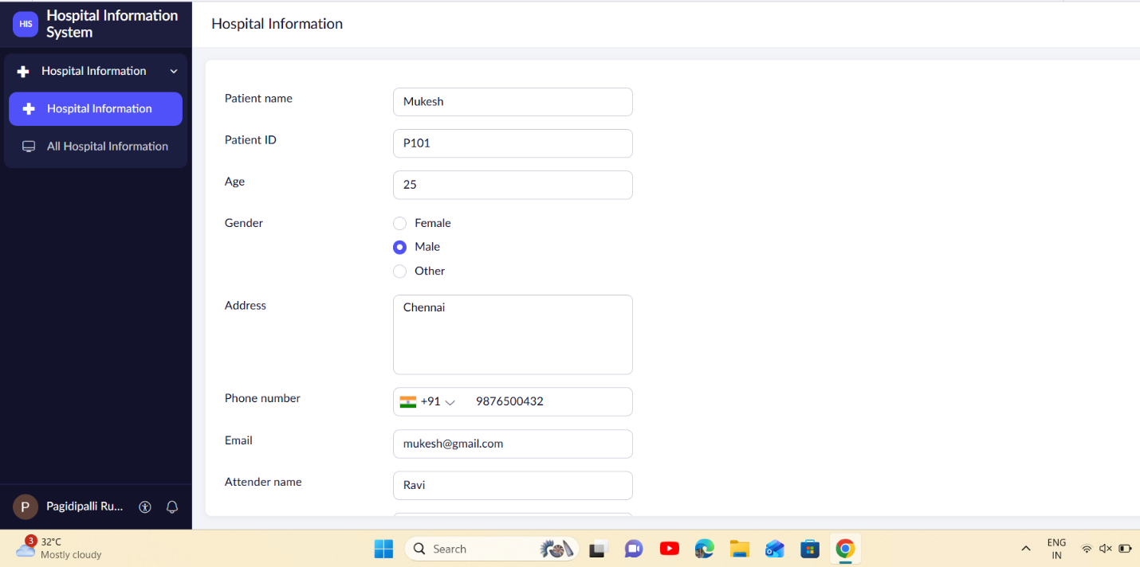
Output
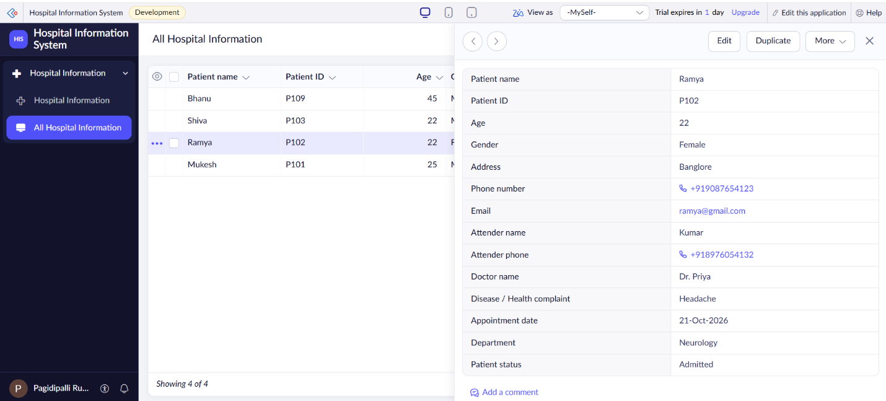

Result
Thus, a cloud-based Hospital Information System was created successfully to maintain patient information and demonstrate SaaS.

